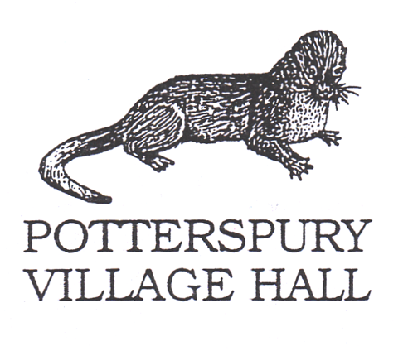

**Special Conditions of Hire during COVID-19**

**Note: These conditions are supplemental to, not a replacement for, the Hall’s usual conditions of hire.**

**SC1:**

You, the hirer, will be responsible for ensuring those attending your activity or event comply with the COVID-19 Secure Guidelines while entering and occupying the hall, as shown on the attached poster which is also displayed at the hall entrance, in particular using the hand sanitiser supplied when entering the hall and after using tissues.

**SC2**:

You undertake to comply with the actions identified in the hall’s risk assessment, of which you have been provided with a copy.

**SC3:**

The hall will be cleaned before you arrive and you will be responsible for cleaning all regularly used surfaces during your period of hire (including tables, wash hand basins, door handles) using either the products supplied or your own ordinary domestic products.

Please take care cleaning electrical equipment. Use cloths - do not spray!

**SC4:**

You will make sure that everyone likely to attend your activity or event understands that they **MUST NOT DO SO** if they or anyone in their household has had COVID-19 symptoms in the last 10 days, and that if they develop symptoms within 48 hours of visiting the premises they **MUST** use the Test and Trace system to alert others with whom they have been in contact. They **MUST** get a COVID-19 test.

**SC5:**

You will keep the premises well ventilated throughout your hire, with windows and doors (except fire doors) open as far as convenient. You will be responsible for ensuring they are all securely closed on leaving.

**SC6**:

You will ensure that no more than **30 (Thirty)** people attend your activity/event, in order that social distancing can be maintained. You will ensure that everyone attending maintains 2m social distancing while waiting to enter the premises, observes the one-way system within the premises (enter through the rear door, leave by the front door), and as far as possible observes social distancing of 1m plus mitigation measures when using more confined areas (e.g. moving and stowing equipment, accessing toilets) which should be kept as brief as possible. You will make sure that no more than **two** people use each suite of toilets at one time.

**SC7**:

You will take particular care to ensure that social distancing is maintained for any persons aged 70 or over or likely to be clinically more vulnerable to COVID-19, including for example keeping a 2m distance around them when going in and out of rooms and ensuring they can access the toilets, kitchen or other confined areas without others being present. For some people, passing another person in a confined space is less risky, but for older people that should be avoided.

**SC8**:

You will position furniture or the arrangement of the room as far as possible to facilitate social distancing of 2m between individual people or groups of up to two households or 1m with mitigation measures such as: seating side by side, with at least one empty chair between each person or household group, rather than face-to-face, and good ventilation. If tables are being used, you will place them so as to maintain social distancing across the table between people from different household groups who are face-to-face e.g. using a wide U-shape.

**SC9:**

You are asked to keep a record of the name and contact telephone number or email of all those who attend your event for a period of 3 weeks after the event and provide the record to NHS Track and trace if required. (People are not obliged to provide details).

**SC10**:

You will be responsible for the disposal of all rubbish created during your hire, including tissues and cleaning cloths, [in the rubbish bags provided insert location before you leave the hall] or [taking all rubbish away with you when you leave the hall].

**SC11**:

You will encourage users to bring their own drinks and food or you will be responsible, if drinks or food are made, for ensuring that all crockery and cutlery is washed in hot soapy water, dried and stowed away where you found it. You will bring your own clean tea towels, so as to reduce risk of contamination between hirers, and take them away. We will provide washing up liquid and washing up cloths.

**SC12:**

We will have the right to close the hall if there are safety concerns relating to COVID-19, for example, if someone who has attended the hall develops symptoms and thorough cleansing is required or if it is reported that the Special Hiring Conditions above are not being complied with, whether by you or by other hirers, or in the event that public buildings are asked or required to close again. If this is necessary, we will do our best to inform you promptly and you will not be charged for this hire.

**SC13**:

In the event of someone becoming unwell with suspected Covid-19 symptoms while at the hall you should remove them to the designated safe area which is the rear meeting room, which should not be used as part of your activity/event under normal circumstances. The person with suspected Covid-19 symptoms should then follow the Government guidance for persons in this situation. Provide tissues and a bin or plastic bag, and a bowl of warm soapy water for handwashing. Ask others in your group to provide contact details if you do not have them and then leave the premises, observing the usual hand sanitising and social distancing precautions, and advise them to launder their clothes when they arrive home. Inform the Mark & Bev Silvester on 01908 543926 0r 07730 564539.

**SC14:** In order to avoid risk of aerosol or droplet transmission you must take steps to avoid people needing to unduly raise their voices to each other, e.g. refrain from playing music or broadcasts at a volume which makes normal conversation difficult.

**SC15:**

Other special points as appropriate.

1. Where a sport, exercise or performing arts activity takes place:

You will organise your activity in accordance with guidance issued by the relevant governing body for your sport or activity

2. Where a group uses their own equipment:

You will ask those attending to bring their own equipment and not share it with other members or you will avoid using equipment, which is difficult to clean, as far as possible. You will ensure that any equipment you provide is cleaned before use and before being stored in the hall’s cupboards.

**SC 16:**

You will encourage all those attending your activity to wear a face covering unless an exemption or other government guidance applies to the activity. A face covering is not required when people are eating or drinking but they should be seated.