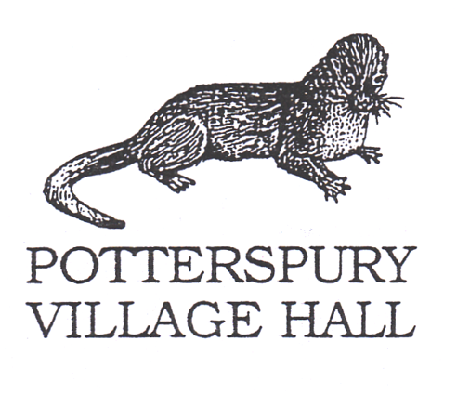

**HELP KEEP THIS HALL COVID-19 SECURE**

1. **You must not enter if you or anyone in your household has COVID-19 symptoms.**
2. **If you develop COVID-19 symptoms within 48 hours** of visiting these premises alert NHS Test and Trace. Alert Mark & Bev Silvester on 01908 543926 or 07730 564539 and alert the organiser of the activity you attended. You **MUST** get a COVID-19 test.
3. **Maintain 2 metres social distancing as far as possible**: Wait behind the marked lines as you go through the entrance hall to your activity and observe the one-way system marked.
4. **Use the hand sanitiser provided** on entering the premises. Clean your hands often. Soap and hand dryers are provided.
5. **Avoid touching your face, nose, or eyes**. Wash your hands if you do.
6. **Face coverings** must be worn unless an exception applies for your activity
7. **“Catch it, Bin it, Kill it”.** Tissues should be disposed of into one of the rubbish bags provided. Then wash your hands.
8. **Check the organisers of your activity have cleaned door handles, tables, other equipment, sinks and surfaces before you arrived.** Keep them clean during your hire use appropriate cleaning materials. We clean all surfaces at the hall between each hire.
9. **Take turns to use confined spaces such as corridors, kitchen and toilet areas**. Standing or sitting next to someone is lower risk than opposite them. Briefly passing another person in a confined space is low risk.
10. **Keep the hall well ventilated. Close doors and windows on leaving**.
11. **Wash your clothes when you get home** to reduce risk of transmission.