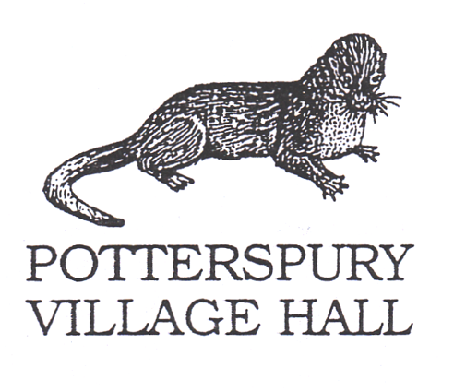

**COVID-19 Risk Assessment for hirers of Village and Community Halls**

This Risk Assessment is intended as a supplement to the Hall’s and individual groups ordinary Risk Assessment.

|  |  |  |  |
| --- | --- | --- | --- |
| **Area of Risk** | **Risk identified** | **Actions to take to mitigate risk** | **Notes** |
| **Cleanliness of hall and equipment, especially after other hires** | Other hirers or hall cleaner have not cleaned hall or equipment used to standard required. One group leaves hall or equipment without cleaning. | Group to check with hall committee when hall is cleaned and to make sure regularly used surfaces are cleaned before, during and after hire e.g. tables, sinks, door and toilet handles. | Can we bring our own equipment? |
| **Managing Social distancing and especially people attending who may be vulnerable** | People do not maintain 2 m social distancing | Advise group they must comply with social distancing as far as possible and use one-way system. Adopt layout advised. Limit numbers using toilets at once. | Should we avoid use of kitchen – ask people to BYO food and drink?  Allow older people time to use toilets without others present. |
| **Respiratory hygiene** | Transmission to other members of group | Catch It, Bin It, Kill It. Encourage group to avoid touching mouth, eyes, and nose. Provide tissues ask all to dispose into a bin or disposable rubbish bag, then wash or sanitise hands. | Remember to bring tissues and hand sanitiser.  Remember to empty any bins used into kitchen bin at end of hire. |
| **Hand cleanliness** | Transmission to other members of group and premises | Advise group to use sanitiser on entering and exiting the hall, to wash hands regularly using soap and hand dryers. |  |
| **Someone falls ill with COVID-19 symptoms** | Transmission to other members of group and premises | Follow hall instructions. Move person to safe area (Small Meeting Room), obtain contacts, inform cleaner. |  |