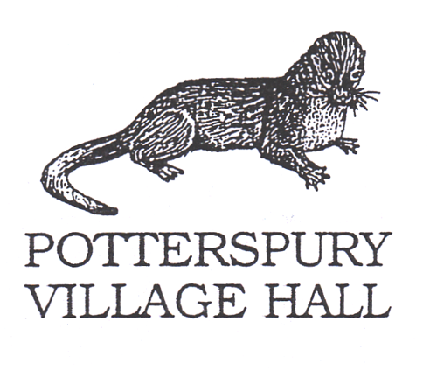

**Help Keep Playground and Play Equipment Covid-19 Secure**

**The Playground area is not supervised, and any equipment used by the Hirer is at their own risk and must be regularly cleaned.**

* **The Playground area is defined as the grass area to the rear of the Hall**
* **Social distancing of 2m MUST always be maintained (or 1m with risk mitigation where 2m is not possible).**
* **Only one child is allowed on each piece of equipment at a time.**
* **No eating or drinking in the playground area**
* **Parents/Carers: You will need to clean the equipment before your child uses it. Use hand sanitiser or wipes to clean your children’s hands before and after use.**
* **Do not touch your face. Remember to cough or sneeze into a tissue. Take tissues home or put them into the bins provided (use an arm if a tissue is not available).**
* **Children’s clothes should be washed when they get home.**
* **Families with clinically vulnerable members: Do NOT use the equipment without first cleaning it.**